California invested heavily in solar power. Now there's so much that other states are sometimes paid to take it
By Ivan Penn June 22, 2017 http://www.latimes.com/projects/la-fi-electricity-solar/
On 14 days during March, Arizona utilities got a gift from California: free solar power.
Well, actually better than free. California produced so much solar power on those days that it paid Arizona to take excess electricity its residents weren’t using to avoid overloading its own power lines.
It happened on eight days in January and nine in February as well. All told, those transactions helped save Arizona electricity customers millions of dollars this year, though grid operators declined to say exactly how much. And California also has paid other states to take power.
The number of days that California dumped its unused solar electricity would have been even higher if the state hadn’t ordered some solar plants to reduce production — even as natural gas power plants, which contribute to greenhouse gas emissions, continued generating electricity.
Solar and wind power production was curtailed a relatively small amount — about 3% in the first quarter of 2017 — but that’s more than double the same period last year. And the surge in solar power could push the number even higher in the future.
Why doesn’t California, a champion of renewable energy, use all the solar power it can generate?
The answer, in part, is that the state has achieved dramatic success in increasing renewable energy production in recent years. But it also reflects sharp conflicts among major energy players in the state over the best way to weave these new electricity sources into a system still dominated by fossil-fuel-generated power.
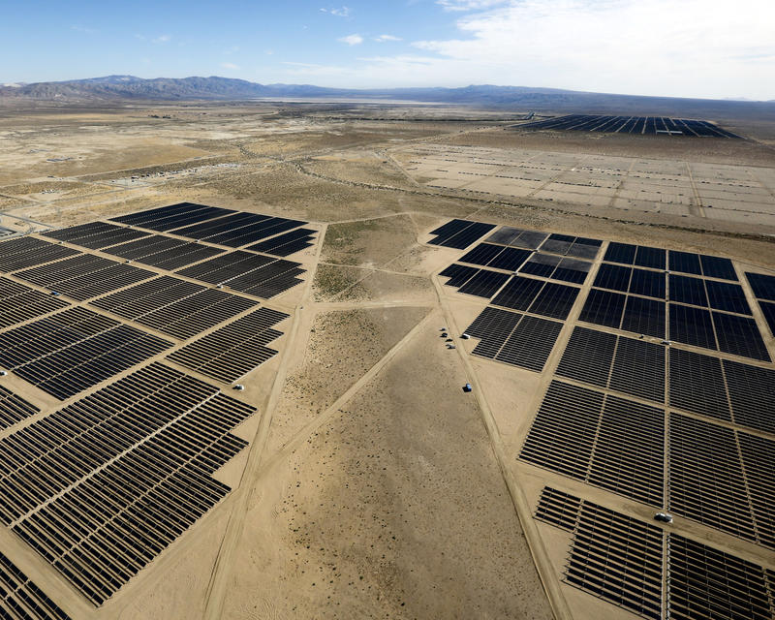In Western Kern County, solar panels on almost two square miles of land form the Beacon Solar Project, owned by the Los Angeles Department of Water and Power. (Mel Melcon/Los Angels Times) 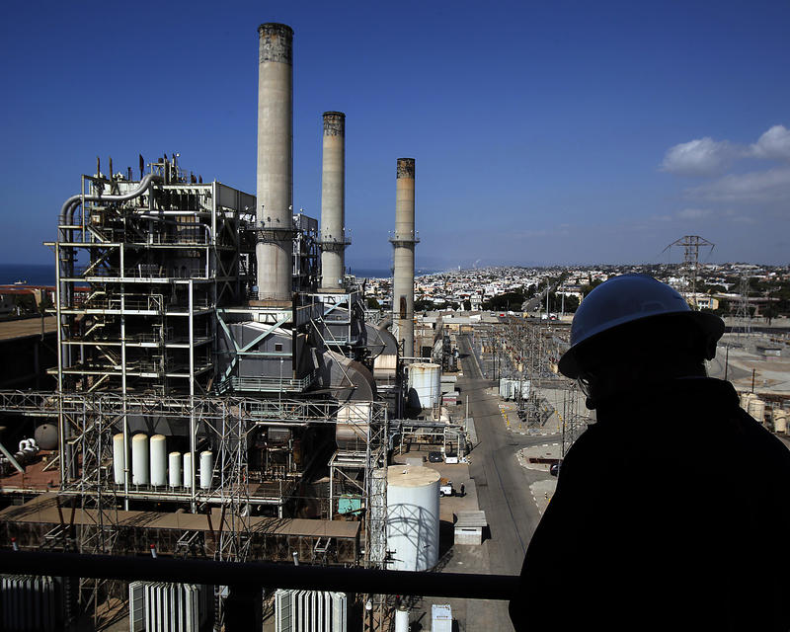City officials and builders in Redondo Beach want a mixed-use development to replace the current natural gas facility. They say there is no need to overhaul the power plant when there is an abundance of clean alternatives. (Rick Loomis/Los Angeles Times)
No single entity is in charge of energy policy in California. This has led to a two-track approach that has created an ever-increasing glut of power and is proving costly for electricity users. Rates have risen faster here than in the rest of the U.S., and Californians now pay about 50% more than the national average.
Perhaps the most glaring example: The California Legislature has mandated that one-half of the state’s electricity come from renewable sources by 2030; today it’s about one-fourth. That goal once was considered wildly optimistic. But solar panels have become much more efficient and less expensive. So solar power is now often the same price or cheaper than most other types of electricity, and production has soared so much that the target now looks laughably easy to achieve.
At the same time, however, state regulators — who act independently of the Legislature — until recently have continued to greenlight utility company proposals to build more natural gas power plants.
State Senate Leader Kevin de Leon (D-Los Angeles) wants Calilfornia to produce 100% of its electricity from clean energy sources such as solar and wind by 2045. (Luis Sinco/Los Angeles Times)
These conflicting energy agendas have frustrated state Senate Leader Kevin de Leon (D-Los Angeles), who opposes more fossil fuel plants. He has introduced legislation that would require the state to meet its goal of 50% of its electricity from renewable sources five years earlier, by 2025. Even more ambitiously, he recently proposed legislation to require 100% of the state’s power to come from renewable energy sources by 2045.
“I want to make sure we don’t have two different pathways,” de Leon said. Expanding clean energy production and also building natural gas plants, he added, is “a bad investment.”
Environmental groups are even more critical. They contend that building more fossil fuel plants at the same time that solar production is being curtailed shows that utilities — with the support of regulators — are putting higher profits ahead of reducing greenhouse gas emissions.
“California and others have just been getting it wrong,” said Leia Guccione, an expert in renewable energy at the Rocky Mountain Institute in Colorado, a clean power advocate. “The way [utilities] earn revenue is building stuff. When they see a need, they are perversely [incentivized] to come up with a solution like a gas plant.”
California and others have just been getting it wrong.
— Leia Guccione, renewable energy expert at the Rocky Mountain Institute
Regulators and utility officials dispute this view. They assert that the transition from fossil fuel power to renewable energy is complicated and that overlap is unavoidable.
They note that electricity demand fluctuates — it is higher in summer in California, because of air conditioning, and lower in the winter — so some production capacity inevitably will be underused in the winter. Moreover, the solar power supply fluctuates as well. It peaks at midday, when the sunlight is strongest. Even then it isn’t totally reliable.
Because no one can be sure when clouds might block sunshine during the day, fossil fuel electricity is needed to fill the gaps. Utility officials note that solar production is often cut back first because starting and stopping natural gas plants is costlier and more difficult than shutting down solar panels.
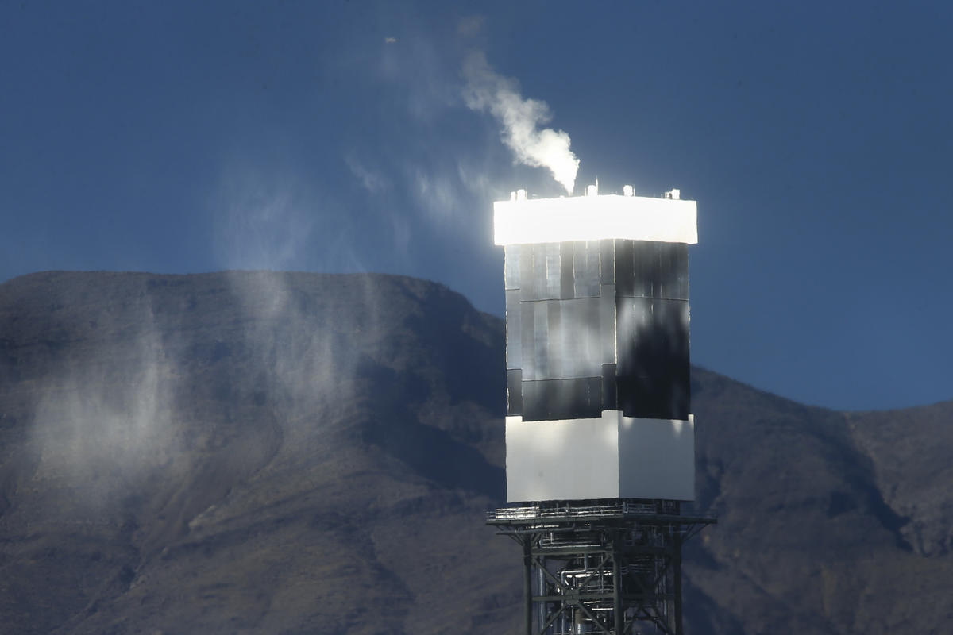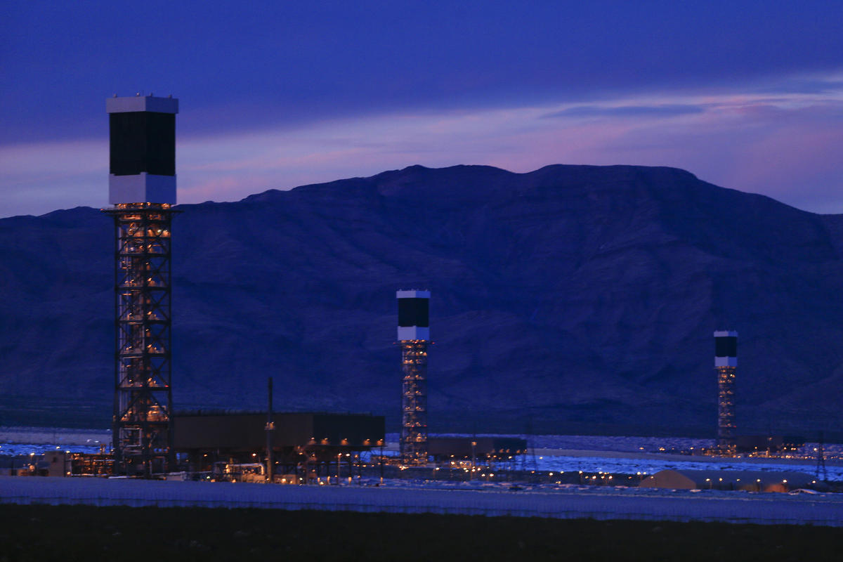
In the Mojave Desert at the California/Nevada border, the Ivanpah Solar Electric Generating System uses 347,000 garage-door-sized mirrors to heat water that powers steam generators. This solar thermal plant — one of the clean energy facilities that helps produce 10% of the state’s electricity. (Mark Boster / Los Angeles Times)
Eventually, unnecessary redundancy of electricity from renewables and fossil fuel will disappear, regulators, utilities and operators of the electric grid say.
“The gas-fired generation overall will show decline,” said Neil Millar, executive director of infrastructure at CAISO, the California Independent System Operator, which runs the electric grid and shares responsibility for preventing blackouts and brownouts. “Right now, as the new generation is coming online and the older generation hasn’t left yet, there is a bit of overlap.”
Support our investigative journalism
The Los Angeles Times has been telling fact from fiction since 1881. Support local investigative reporting like this story by subscribing today. Start getting full access to our signature journalism for just 99 cents for the first eight weeks.
Utility critics acknowledge these complexities. But they counter that utilities and regulators have been slow to grasp how rapidly technology is transforming the business. A building slowdown is long overdue, they argue.
Despite a growing glut of power, however, authorities only recently agreed to put on hold proposals for some of the new natural gas power plants that utilities want to build to reconsider whether they are needed.
A key question in the debate is when California will be able to rely on renewable power for most or all of its needs and safely phase out fossil fuel plants, which regulators are studying.
The answer depends in large part on how fast battery storage improves, so it is cheaper and can store power closer to customers for use when the sun isn’t shining. Solar proponents say the technology is advancing rapidly, making reliance on renewables possible far sooner than previously predicted, perhaps two decades or even less from now — which means little need for new power plants with a life span of 30 to 40 years.
Calibrating this correctly is crucial to controlling electricity costs.
“It’s not the renewables that’s the problem. It’s the state’s renewable policy that’s the problem,” said Gary Ackerman, president of the Western Power Trading Forum, an association of independent power producers. “We’re curtailing renewable energy in the summertime months. In the spring, we have to give people money to take it off our hands.”

Not long ago, solar was barely a rounding error for California’s energy producers.
In 2010, power plants in the state generated just over 15% of their electricity production from renewable sources. But that was mostly wind and geothermal power, with only a scant 0.5% from solar. Now that overall amount has grown to 27%, with solar power accounting for 10%, or most of the increase. The solar figure doesn’t include the hundreds of thousands of rooftop solar systems that produce an additional 4 percentage points, a share that is ever growing.
@latimesgraphics Source: Energy Information Administration California's solar boom The share of the state’s power generated by solar utilities and rooftop panels has skyrocketed in recent years. 0 5 10 15% Rooftop solar Utility solar '16 '15 '14 '13 '12 '11 '10 '09 '08 '07 '06 '05 '04 '03 '02 '01 % generated by solar utilities % generated by rooftop panels Note: Rooftop panels were not tracked by the federal government prior to 2014. 2016Solar utilities: 9.6%Rooftop panels: 4.2%
Behind the rapid expansion of solar power: its plummeting price, which makes it highly competitive with other electricity sources. In part that stems from subsidies, but much of the decline comes from the sharp drop in the cost of making solar panels and their increased efficiency in converting sunlight into electricity.
The average cost of solar power for residential, commercial and utility-scale projects declined 73% between 2010 and 2016. Solar electricity now costs 5 to 6 cents per kilowatt-hour — the amount needed to light a 100-watt bulb for 10 hours — to produce, or about the same as electricity produced by a natural gas plant and half the cost of a nuclear facility, according to the U.S. Energy Information Administration.
Fly over the Carrizo Plain in California’s Central Valley near San Luis Obispo and you’ll see that what was once barren land is now a sprawling solar farm, with panels covering more than seven square miles — one of the world’s largest clean-energy projects. When the sun shines over the Topaz Solar Farm, the shimmering panels produce enough electricity to power all of the residential homes in a city the size of Long Beach, population 475,000.
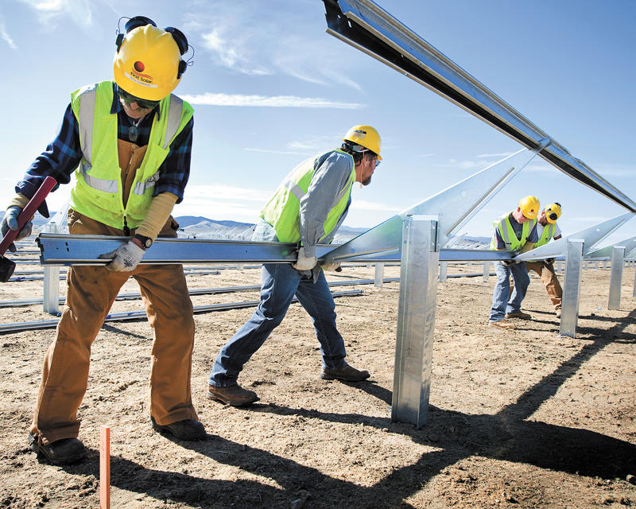
A construction crew installs rails to support some of the 9 million solar panels at the Topaz Solar Farm near San Luis Obispo. (Joe Johnston / San Luis Obispo Tribune) 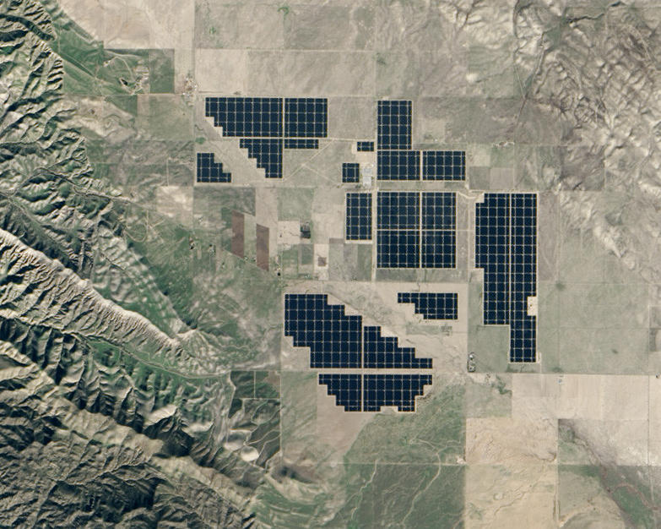
The Topaz Solar Farm, one of the world’s largest solar plants, blankets the Carrizo Plain in the Central Valley. It supplies electricity to Pacific Gas & Electric Co. (NASA)
Other large-scale solar operations blanket swaths of the Mojave Desert, which has increasingly become a sun-soaking energy hub. The Beacon solar project covers nearly two square miles and the Ivanpah plant covers about five and a half square miles.
The state’s three big shareholder-owned utilities now count themselves among the biggest solar power producers. Southern California Edison produces or buys more than 7% of its electricity from solar generators, Pacific Gas & Electric 13% and San Diego Gas & Electric 22%.
Similarly, fly over any sizable city and you’ll see warehouses, businesses and parking lots with rooftop solar installations, and many homes as well.
With a glut of solar power at times, CAISO has two main options to avoid a system overload: order some solar and wind farms to temporarily halt operations or divert the excess power to other states.
That’s because too much electricity can overload the transmission system and result in power outages, just as too little can. Complicating matters is that even when CAISO requires large-scale solar plants to shut off panels, it can’t control solar rooftop installations that are churning out electricity.
CAISO is being forced to juggle this surplus more and more.
In 2015, solar and wind production were curtailed about 15% of the time on average during a 24-hour period. That rose to 21% in 2016 and 31% in the first few months of this year. The surge in solar production accounts for most of this, though heavy rainfall has increased hydroelectric power production in the state this year, adding to the surplus of renewables.
July ’14 Jan. ’15 July Jan. ’16 July Jan. ’17 0 30K 60K 90K Volume of power curtailments (in megawatt-hours) P. Krishnakumar / @latimesgraphics Source: Cal-ISO March ’1782,083megawatt-hours Pulling the plug California’s clean energy supply is growing so fast that solar and wind producers are increasingly being ordered to halt production.
Even when solar production is curtailed, the state can produce more than it uses, because it is difficult to calibrate supply and demand precisely. As more homeowners install rooftop solar, for example, their panels can send more electricity to the grid than anticipated on some days, while the state’s overall power usage might fall below what was expected.
This means that CAISO increasingly has excess solar and wind power it can send to Arizona, Nevada and other states.
When those states need more electricity than they are producing, they pay California for the power. But California has excess power on a growing number of days when neighboring states don’t need it, so California has to pay them to take it. CAISO calls that “negative pricing.”
Why does California have to pay rather than simply give the power away free?
Full coverage: California’s energy glut
View the interactive graphic
When there isn’t demand for all the power the state is producing, CAISO needs to quickly sell the excess to avoid overloading the electricity grid, which can cause blackouts. Basic economics kick in. Oversupply causes prices to fall, even below zero. That’s because Arizona has to curtail its own sources of electricity to take California’s power when it doesn’t really need it, which can cost money. So Arizona will use power from California at times like this only if it has an economic incentive — which means being paid.
In the first two months of this year, CAISO paid to send excess power to other states seven times more often than same period in 2014. “Negative pricing” happened in an average of 18% of all sales, versus about 2.5% in the same period in 2014.
Most “negative pricing” typically has occurred for relatively short periods at midday, when solar production is highest.
But what happened in March shows how the growing supply of solar power could have a much greater impact in the future. The periods of “negative pricing” lasted longer than in the past — often for six hours at a time, and once for eight hours, according to a CAISO report.
The excess power problem will ease somewhat in the summer, when electricity usage is about 50% higher in California than in the winter.
But CAISO concedes that curtailments and “negative pricing” is likely to happen even more often in the future as solar power production continues to grow, unless action is taken to better manage the excess electricity.
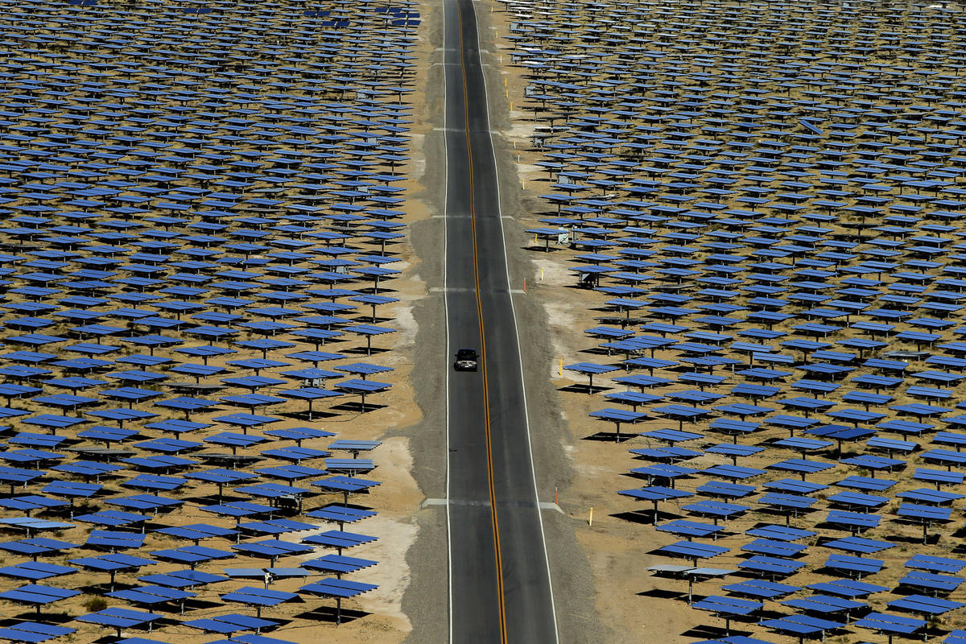
The sprawling Ivanpah Solar Electric Generating System, owned by NRG Energy and BrightSource Energy, occupies 5.5 square miles in the Mojave Desert. The plant can supply electricity to 180,000 Pacific Gas & Electric and Southern California Edison customers. (Mark Boster/Los Angeles Times)
Arizona’s largest utility, Arizona Public Service, is one of the biggest beneficiaries of California’s largesse because it is next door and the power can easily be sent there on transmission lines.
On days that Arizona is paid to take California’s excess solar power, Arizona Public Service says it has cut its own solar generation rather than fossil fuel power. So California’s excess solar isn’t reducing greenhouse gases when that happens.
CAISO says it does not calculate how much it has paid others so far this year to take excess electricity. But its recent oversupply report indicated that it frequently paid buyers as much as $25 per megawatt-hour to get them to take excess power, according to the Energy Information Administration.
That’s a good deal for Arizona, which uses what it is paid by California to reduce its own customers’ electricity bills. Utility buyers typically pay an average of $14 to $45 per megawatt-hour for electricity when there isn’t a surplus from high solar power production.

With solar power surging so much that it is sometimes curtailed, does California need to spend $6 billion to $8 billion to build or refurbish eight natural gas power plants that have received preliminary approval from regulators, especially as legislative leaders want to accelerate the move away from fossil fuel energy?
The answer depends on whom you ask.
Utilities have repeatedly said yes. State regulators have agreed until now, approving almost all proposals for new power plants. But this month, citing the growing electricity surplus, regulators announced plans to put on hold the earlier approvals of four of the eight plants to determine if they really are needed.
Big utilities continue to push for all of the plants, maintaining that building natural gas plants doesn’t conflict with expanding solar power. They say both paths are necessary to ensure that California has reliable sources of power — wherever and whenever it is needed.
The biggest industrial solar power plants, they note, produce electricity in the desert, in some cases hundreds of miles from population centers where most power is used.
At times of peak demand, transmission lines can get congested, like Los Angeles highways. That’s why CAISO, utilities and regulators argue that new natural gas plants are needed closer to big cities. In addition, they say, the state needs ample electricity sources when the sun isn’t shining and the wind isn’t blowing enough.
Utility critics agree that some redundancy is needed to guarantee reliability, but they contend that the state already has more than enough.
California has so much surplus electricity that existing power plants run, on average, at slightly less than one-third of capacity. And some plants are being closed decades earlier than planned.
As for congestion, critics note that the state already is crisscrossed with an extensive network of transmission lines. Building more plants and transmission lines wouldn’t make the power system much more reliable, but would mean higher profits for utilities, critics say.
That is what the debate is about, said Jaleh Firooz, a power industry consultant who previously worked as an engineer for San Diego Gas & Electric for 24 years and helped in the formation of CAISO.
“They have the lopsided incentive of building more,” she said.
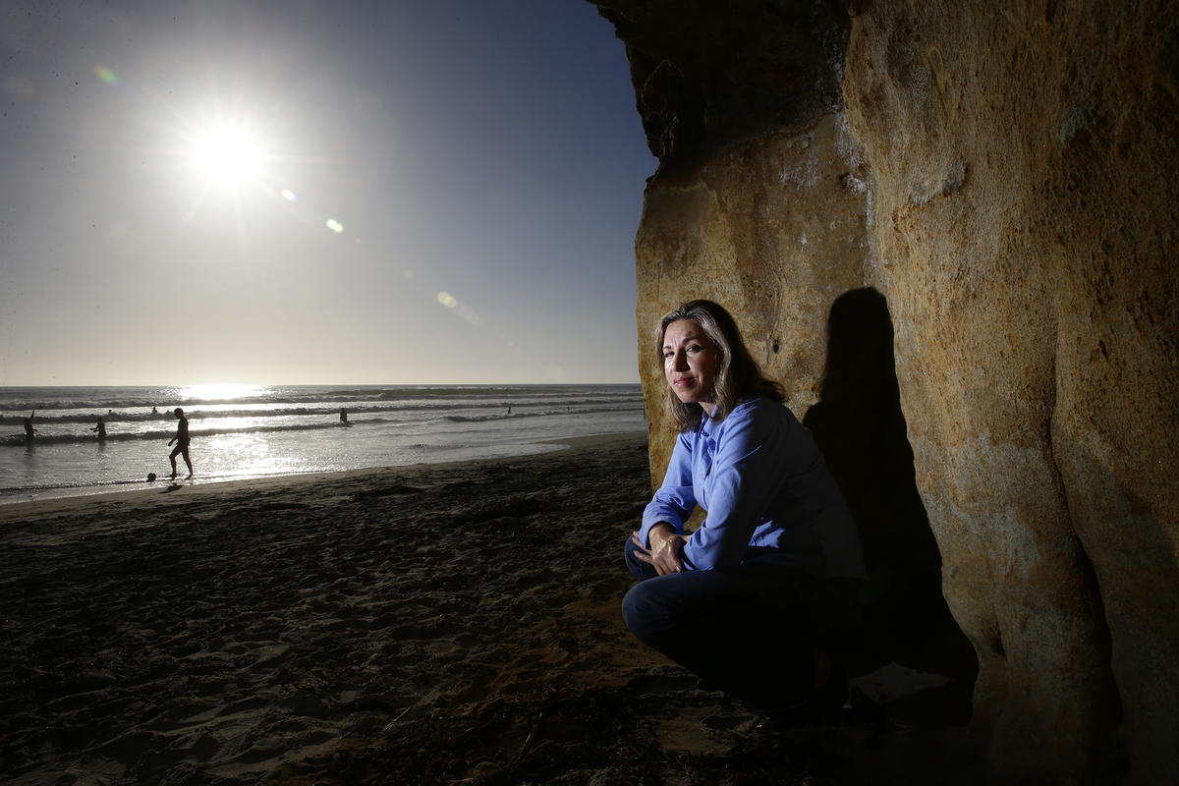
Jaleh Firooz, who worked 24 years as an engineer for San Diego Gas & Electric Co., says utilities seeking higher profits “have the lopsided incentive of building more” power plants and transmission lines. (Robert Gauthier/Los Angeles Times)
The reason: Once state regulators approve new plants or transmission lines, the cost is now built into the amount that the utility can charge electricity users — no matter how much or how little it is used.
Given that technology is rapidly tilting the competitive advantage toward solar power, there are less expensive and cleaner ways to make the transition toward renewable energy, she said.
To buttress her argument, Firooz pointed to a battle in recent years over a natural gas plant in Redondo Beach.
Independent power producer AES Southland in 2012 proposed replacing an aging facility there with a new one. The estimated cost: $250 million to $275 million, an amount that customers would pay off with higher electricity bills.
CAISO and Southern California Edison, which was going to buy power from the new plant, supported it as necessary to protect against potential power interruptions. Though solar and wind power production was increasing, they said those sources couldn’t be counted on because their production is variable, not constant.
The California Public Utilities Commission approved the project, agreeing that it was needed to meet the long-term electricity needs in the L.A. area.
Support our investigative journalism
The Los Angeles Times has been telling fact from fiction since 1881. Support local investigative reporting like this story by subscribing today. Start getting full access to our signature journalism for just 99 cents for the first eight weeks.
But the California Coastal Conservancy, a conservation group opposed to the plant, commissioned an analysis by Firooz to determine how vital it was. Her conclusion: not at all.
Firooz calculated that the L.A. region already had excess power production capacity — even without the new plant — at least through 2020.
Along with the cushion, her report found, a combination of improved energy efficiency, local solar production, storage and other planning strategies would be more than sufficient to handle the area’s power needs even as the population grew.
She questioned utility arguments.
“In their assumptions, the amount of capacity they give to the solar is way, way undercut because they have to say, ‘What if it’s cloudy? What if the wind is not blowing?’ ” Firooz explained. “That’s how the game is played. You build these scenarios so that it basically justifies what you want.”
In their assumptions, the amount of capacity they give to the solar is way, way undercut because they have to say, ‘What if it’s cloudy?’
— Jaleh Firooz, power-industry consultant
Undeterred, AES Southland pressed forward with its proposal. In 2013, Firooz updated her analysis at the request of the city of Redondo Beach, which was skeptical that a new plant was needed. Her findings remained the same.
Full coverage: California’s energy glut
View the interactive graphic
Nonetheless, the state Public Utilities Commission approved the project in March 2014 on the grounds that it was needed. But the California Energy Commission, another regulatory agency whose approval for new plants is required along with the PUC’s, sided with the critics. In November 2015 it suspended the project, effectively killing it.
Asked about the plant, AES said it followed the appropriate processes in seeking approval. It declined to say whether it still thinks that a new plant is needed.
The existing facility is expected to close in 2020.
A March 2017 state report showed why critics are confident that the area will be fine without a new plant: The need for power from Redondo Beach’s existing four natural gas units has been so low, the state found, that the units have operated at less than 5% of their capacity during the last four years.

