Shale's the Wild Horse OPEC Can't Tame
Julian Lee is an oil strategist for Bloomberg First Word. Previously he worked as a senior analyst at the Centre for Global Energy Studies.
By Julian Lee April 23, 2017 3:00 AM EDT https://www.bloomberg.com/gadfly/articles/2017-04-23/u-s-shale-s-the-wild-horse-that-opec-just-can-t-tame
It was all so simple. By lifting restraints on output, Saudi Arabia would stop subsidizing high-cost oil producers and halt the rapid rise in U.S. production that was eating into OPEC's market share. At least, that was the logic back in November 2014.
But things haven't gone according to plan. OPEC's four-month experiment with production curbs has failed. More worryingly, the strength of shale's rebound suggests that OPEC faces a long-term struggle against this new source of supply in an industry where technological advances are the norm and today's niche play becomes the next decade's global standard.
Even when the group restored production curbs last year, Saudi Energy Minister Khalid al-Falih said he didn’t expect a big supply response from American shale producers in 2017. In fact, it turns out that response had already begun, and it is much stronger than anyone had expected.
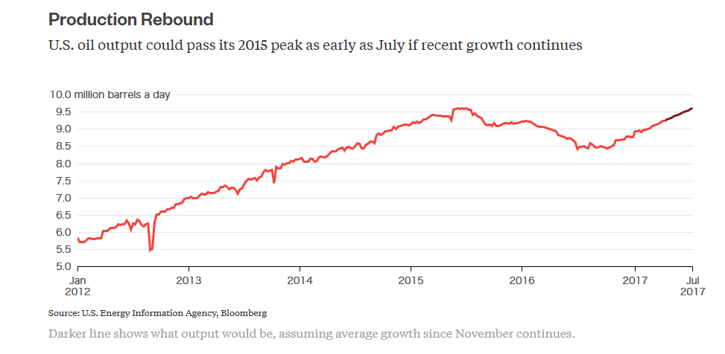Total U.S. crude production has risen by more than 550,000 barrels a day in the 20 weeks since OPEC decided to cut output, according to weekly Department of Energy data. Much of that increase has come from shale formations. If this rate of growth -- a little under 30,000 barrels a day of new supply each week -- continues, U.S. output could top its recent peak of 9.61 million barrels a day shortly after OPEC meets on May 25 to consider its next move.
That is bad enough for OPEC producers, but the picture just gets worse for them each month. The DoE publishes a monthly outlook and its views on domestic production are evolving rapidly -- and not in a way that suits OPEC.
Its latest forecast, published on April 11, pegs U.S. oil production at 9.24 million barrels a day by July. That is half a million barrels a day higher than it was forecasting for that month in November 2016, just before OPEC decided to restore output restraint. Its outlook for December 2017 has increased by 700,000 barrels a day over the same period.
ACCELERATING GROWTH
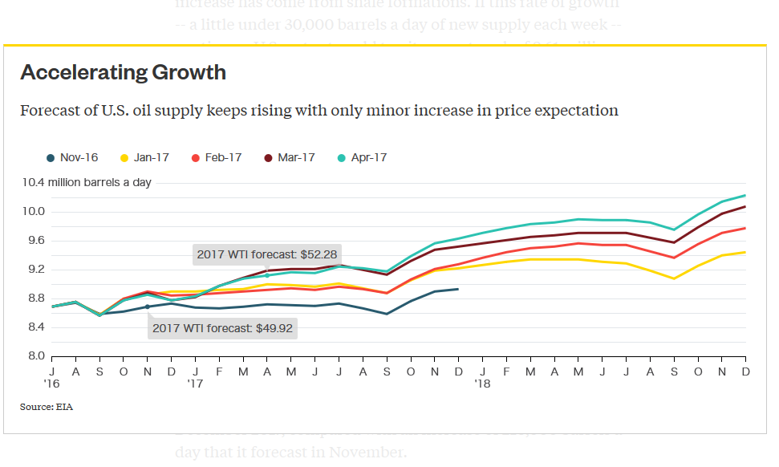
The Energy Information Administration now sees U.S. production rising by 860,000 barrels a day in the 12 months to December 2017, compared with an increase of 210,000 barrels a day that it forecast in November.
What should be even more worrying for OPEC is that the stronger outlook for U.S. production has little to do with higher price expectations. Back in November the EIA assumed an average 2017 WTI price of $49.92 per barrel. That estimate has risen to just $52.28 in this month's forecast.
The producer group may be able to drain some of the excess oil inventory by extending its output cuts through the second half of the year. Although spectacular, the rise in U.S. output will not be enough to offset lower OPEC flows as refiners boost runs to meet summer gasoline demand.
However, compliance with the cuts may already have been as good it gets. Indeed many OPEC members will find restraint more challenging in the second half of the year. Several have reached their lower targets so far by bringing forward field maintenance, which they won't need to repeat later in the year. Saudi Arabia will also have a tougher time -- its supply cuts came when domestic demand was already at a seasonal low. This demand will pick up as summer temperatures rise, so continued output restraint will have a much bigger impact on the export revenues the kingdom depends upon.
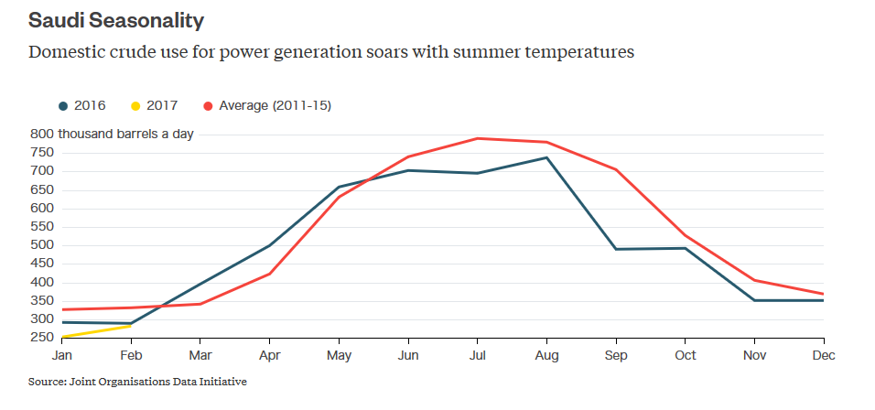But the worry for OPEC goes well beyond the current market imbalance. The shale industry is in its infancy. True, the techniques of horizontal drilling and hydraulic fracturing have been used in the oil industry for decades, but their widespread application to shale formations is not much more than five years old. What should really be giving OPEC oil ministers sleepless nights are the parallels between shale and other industry sectors. It would be extremely rash to assume that advances in technology and geographical spread that we have seen in deep-water oil production, for example, will not apply to the shale sector.
OPEC's battle with shale has only just begun and initial evidence suggests it may already have been lost.

