Tesla Gives the California Power Grid a Battery Boost
By DIANE CARDWELL JAN. 30, 2017 https://www.nytimes.com/2017/01/30/business/energy-environment/battery-storage-tesla-california.html?emc=edit_th_20170131&nl=todaysheadlines&nlid=28869750
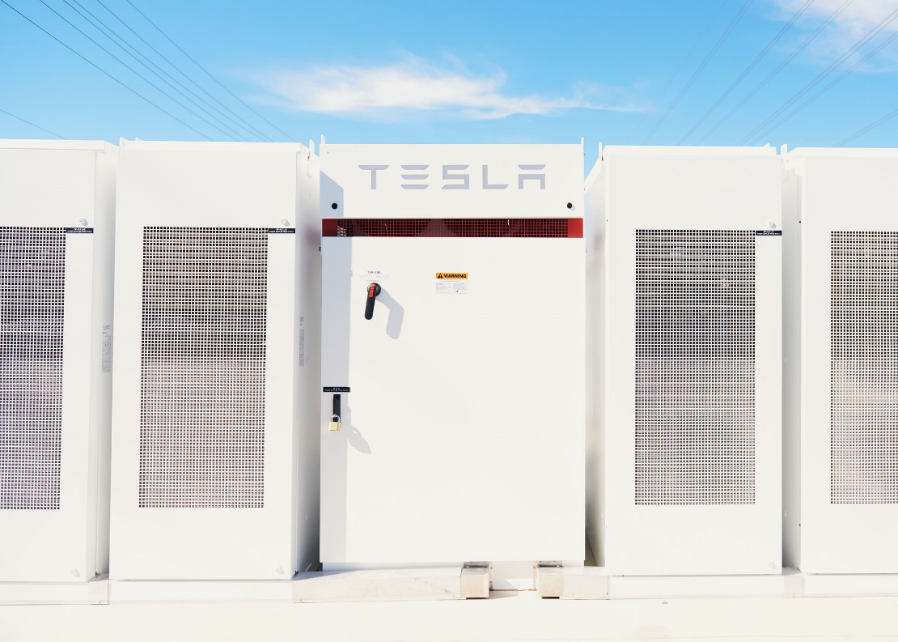
An installation of Tesla batteries is connected to distribution circuits at Southern California Edison’s Mira Loma substation in Ontario, Calif., about 40 miles east of Los Angeles. Credit Jake Michaels for The New York Times
Just off a freeway in Southern California, 396 refrigerator-size stacks of Tesla batteries, encased in white metal, have been hastily erected with a new mission: to suck up electricity from the grid during the day and feed it back into the system as needed, especially in the evening.
The installation, capable of powering roughly 15,000 homes over four hours, is part of an emergency response to projected energy shortages stemming from a huge leak at a natural gas storage facility.
The project, which officially came online Monday but began operating at the end of last year, is an important and surprising demonstration of how utilities can use enormous collections of batteries in place of conventional power plants.
It is also an indication of how rapidly Tesla is moving to transform itself from a maker of luxury electric cars into a multifaceted clean-energy company.
“I had relatively limited expectations for the battery industry in advance of 2020,” said Michael J. Picker, president of the California Public Utilities Commission. “I thought that it would not really accelerate and begin to penetrate the electric grid or the transportation world for a while to come. Once again, technology is clearly moving faster than we can regulate.”
Manufactured, shipped, installed and readied for operation in roughly three months, the batteries are connected to distribution circuits at Southern California Edison’s Mira Loma substation in an industrial section of Ontario, Calif., about 40 miles east of Los Angeles.
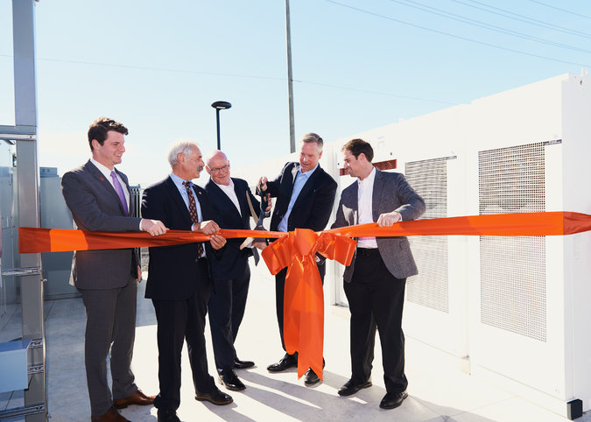
The project, which officially came online Monday, is a demonstration of how utilities can use enormous collections of batteries in place of conventional power plants. Credit Jake Michaels for The New York Times
Tesla has developed or won contracts for similar installations elsewhere in California, and in a handful of other American states and overseas. And although the company had imported some components, it now makes and puts together all of the major parts of each battery assemblage, called the Powerpack, at its Gigafactory outside Sparks, Nev.
“Essentially, we can go and pour a slab and install the basic wiring, but each one of our Powerpacks is quite self-contained,” said J. B. Straubel, Tesla’s chief technical officer.
All of the batteries, cooling and safety systems, and other equipment are inside the casings, ready to load onto delivery trucks. “Our vehicle work lays a lot of the architectural foundation for this,” Mr. Straubel said. “It’s not as if we’re starting from scratch.”
The Mira Loma project came together quickly in part because California’s utilities already had several battery storage projects in the works, some involving Tesla. As the state has aggressively pursued the use of renewable energy sources, especially solar, to combat climate change, the traditional patterns of supply and demand have been upended.
California is on track to have an overabundance of energy during the day, when its many solar panels are producing energy, but that supply drops sharply as the sun sets, precisely when demand rises, with residents heading home to use appliances and, increasingly, to charge cars.
The state’s aging nuclear plants have been closed or are being phased out, putting even more pressure on utilities to find other ways to feed the grid. Storage is a natural solution, utility executives say, helping to smooth variations in the power flow from rooftop customers and when solar falls off and conventional plants have not yet filled the gap.
Ronald O. Nichols, president of Southern California Edison, said the utility was looking for more ways to use that energy, instead of curtailing solar production, “which makes no greenhouse-gas-reduction sense.” By 2024, the California system is expected to have far too much energy for at least a few hours each day, he said, adding, “We want to find a way to use that energy productively, and battery storage is certainly a piece of that.”
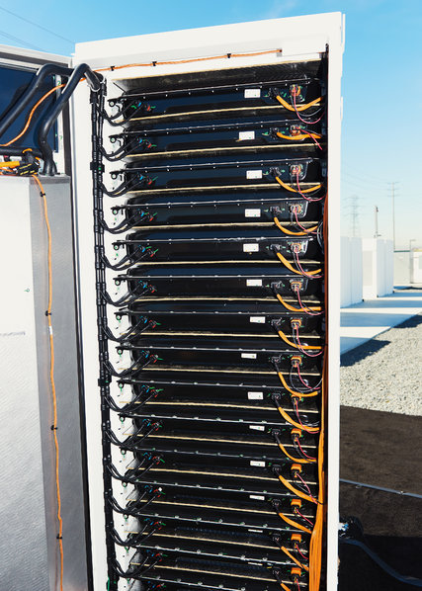
Although Tesla had imported some components, it now makes and puts together all of the major parts of each battery assemblage, called the Powerpack. Credit Jake Michaels for The New York Times
The utility’s need for storage was amplified after the sudden closing of the San Onofre Nuclear Generating Station in 2013. To fill that gap — and fulfill a state mandate to add storage to its energy portfolio — the utility awarded several contracts for battery storage.
When the scale of the 2015 leak at the Aliso Canyon gas storage facility in the San Fernando Valley became clear, the commission moved to streamline the process for storage projects. That led to the Tesla project at the Mira Loma substation and an electricity purchase agreement from a similar battery project that AltaGas had installed at its natural gas generator in Pomona. Another large battery installation that was part of the response, from a company called AES for a separate regional utility, San Diego Gas & Electric, is nearing full operation in Escondido.
Although battery storage is still costly, its price can be comparable to that of the natural gas plants known as peakers, which can ramp up and down quickly to handle spikes in demand, utility executives say. Neither they nor Tesla executives would disclose the price of the project, but it was particularly appealing because Southern California is constrained by geography and strict environmental regulations in building power plants.
Given the cost of land and the air quality requirements that limit the number of hours plants can operate, Mr. Nichols of Southern California Edison said, building natural gas plants can be expensive.
Batteries are more flexible and do not require the same infrastructure, including water and fuel supply conduits, as conventional generators, avoiding the need for long environmental reviews and permitting processes.
As a result, energy analysts say, battery installations are likely to become more common, whether to vary the number of power supply options to enhance reliability or as part of a move away from fossil fuels to meet climate and other environmental goals.
As an early adopter of renewable technologies, particularly solar, California has been willing to pay high prices and has in turn helped lower them for other markets, said Swami Venkataraman, a senior vice president at Moody’s Investors Service who analyzes the utility sector. He cited parallels in how the state was approaching storage.
“California is looking to the future, where this would start a cycle where storage becomes cheaper all the time,” he said. “In the long run, they would have less need — and maybe no need — for new natural gas generation.”

