Texas Oil Fields Rebound From Price Lull, but Jobs Are Left Behind
The industry is embracing technology, and finding new ways to pare the labor
force. But as jobs go away, what of presidential promises to bring them back?
By CLIFFORD KRAUSS FEB. 19, 2017 https://www.nytimes.com/2017/02/19/business/energy-environment/oil-jobs-technology.html?emc=edit_th_20170220&nl=todaysheadlines&nlid=28869750&_r=0
MIDLAND, Tex. — In the land where oil jobs were once a guaranteed road to security for blue-collar workers, Eustasio Velazquez’s career has been upended by technology.
For 10 years, he laid cables for service companies doing seismic testing in the search for the next big gusher. Then, powerful computer hardware and software replaced cables with wireless data collection, and he lost his job. He found new work connecting pipes on rigs, but lost that job, too, when plunging oil prices in 2015 forced the driller he worked for to replace rig hands with cheaper, more reliable automated tools.
“I don’t see a future,” Mr. Velazquez, 44, said on a recent afternoon as he stooped over his shopping cart at a local grocery store. “Pretty soon every rig will have one worker and a robot.”
Oil and gas workers have traditionally had some of the highest-paying blue-collar jobs — just the type that President Trump has vowed to preserve and bring back. But the West Texas oil fields, where activity is gearing back up as prices rebound, illustrate how difficult it will be to meet that goal. As in other industries, automation is creating a new demand for high-tech workers — sometimes hundreds of miles away in a control center — but their numbers don’t offset the ranks of field hands no longer required to sling chains and lift iron.
So while there is a general sense of relief in the oil patch that a recovery is gaining momentum, discussions at company meetings and family kitchen tables are rife with aching worries, especially among those who are middle-aged with no more than a high school education.
Roughly 163,000 oil jobs were lost nationally from the 2014 peak, or about 30 percent of the total, while oil prices plummeted, at one point by as much as 70 percent. The job losses just in Texas, the most productive oil-producing state, totaled 98,000.
Several thousand workers have come back to work in recent months as the price of oil has begun to rise again, but energy experts say that between a third and a half of the workers who lost their jobs are not returning. Many have migrated to construction or even jobs in renewable energy, like wind power.
“People have left the industry, and they are not coming back,” said Michael Dynan, vice president for portfolio and strategic development at Schramm, a Pennsylvania manufacturer of drilling rigs. “If it’s a repetitive task, it can be automated, and I don’t need someone to do that. I can get a computer to do that.”
Indeed, computers now direct drill bits that were once directed manually. The wireless technology taking hold across the oil patch allows a handful of geoscientists and engineers to monitor the drilling and completion of multiple wells at a time — onshore or miles out to sea — and supervise immediate fixes when something goes wrong, all without leaving their desks. It is a world where rigs walk on their own legs and sensors on wells alert headquarters to a leak or loss of pressure, reducing the need for a technician to check.
And despite all the lost workers, United States oil production is galloping upward, to nine million barrels a day from 8.6 million in September. Nationwide, with a bit more than one-third as many rigs operating as in 2014, production is not even down 10 percent from record levels.
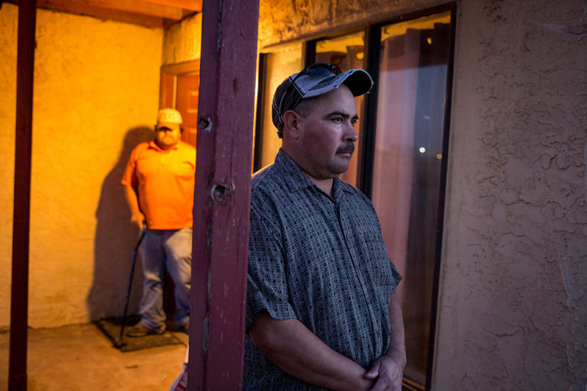
Eustasio Velazquez at his home in Andrews, Tex. He has lost oil jobs as the technology in the industry advances. Credit Ilana Panich-Linsman for The New York Times
Some of the best wells here in the Permian Basin that three years ago required an oil price of over $60 a barrel for an operator to break even now need about $35, well below the current price of about $53.
Much of the technology has been developed by the aviation and automotive industries, along with deepwater oil exploration, over more than a decade. But companies drilling on land were slow to adapt until oil prices crashed and companies needed to get efficient quickly or go out of business.
All the big companies, and many smaller ones, have organized teams of technicians that collect well and tank data to develop complex algorithms enabling them to duplicate the design for the most productive wells over and over, and to repair valves and other parts before they break down.
The result is improved production and safety, but also a far smaller work force, and one that is increasingly morphing from muscle to brain power.
Pioneer Natural Resources, one of the most productive West Texas producers, has slashed the number of days to drill and complete wells so drastically that it has been able to cut costs by 25 percent in wells completed since early 2015. The typical rig that drilled eight to 12 wells a year just a few years ago now drills up to 16. Last year, the company added nearly 240 wells to its Permian Basin inventory without adding new employees.
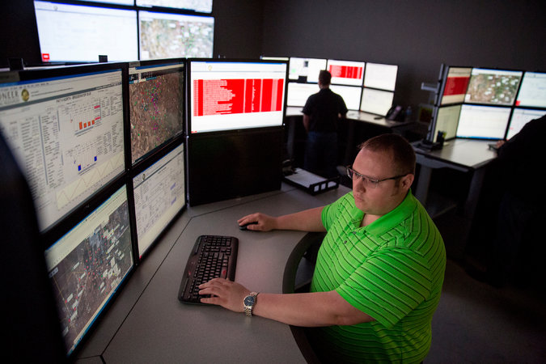
Ryan Grant is a control room operator for Pioneer Natural Resources in Midland, helping manage all of the company’s drilling sites in 21st-century style. Credit Ilana Panich-Linsman for The New York Times
The faster operations, Pioneer executives say, are due in large part to more effective well planning and drill steering. Both have been made possible by the real-time computer connections between the rig and top geoscientists back at corporate headquarters and intense analysis of the data gathered at every well.
The laborious task of checking tank levels by climbing a flight of steps and popping open a series of latches, for instance, has been replaced by pressing a few icons on a computer touch screen. A fully automated water pump station installed last summer is intended to save hundreds of truck trips every day hauling water for hydraulically fracturing wells, yielding diesel and labor cost savings.
“We want to transform our work force to the point where we need to hire fewer people,” said Joey Hall, Pioneer’s executive vice president for Permian operations. Improved computing streamlines operations, he noted, and lets technicians optimally space their wells and more accurately perforate the sweet spots of shale veins to squeeze every drop of oil out of the ground.
“We’re heading toward artificial intelligence and machine learning, analyzing thousands of algorithms,” Mr. Hall added, sounding more like a Silicon Valley futurologist than a wildcatter. “Through repetitive operations, you learn the patterns, and through patterns you learn to make automated decisions.”
With the loss of manual jobs has come a transformation in the job force, with demand growing for more data analysts, math scientists, communications specialists and robotic design engineers. In the last two years, ABB, the Swiss technology company, has opened two plants in Houston for assembling and packaging robotics and integrating advanced instrumentation into oil field operations.
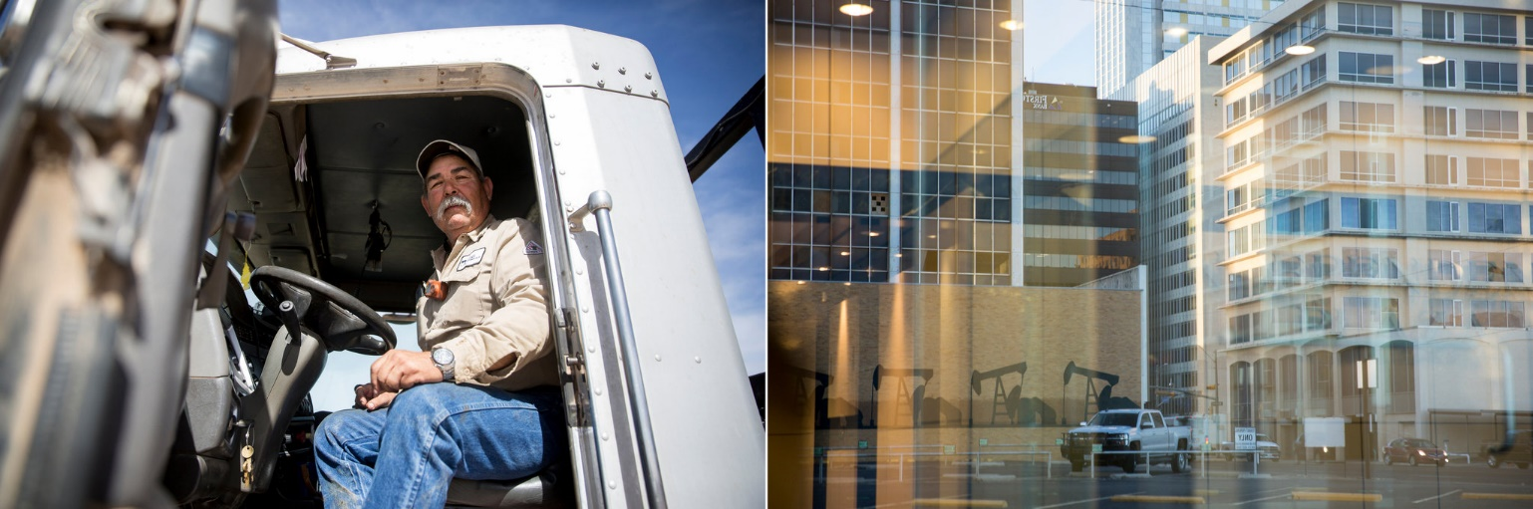
Rodrigo Urias has been working in the oil industry since the early 1980s. He drives a pump truck, and said he had struggled to keep up with changing technologies. Credit Ilana Panich-Linsman for The New York Times
GE Oil and Gas opened a technology center in Oklahoma City in October to place scientists closer to the oil fields to research and apply new digital industrial technologies for exploration and production. Among its many projects is an experiment to use drones to inspect equipment and identify methane leaks on oil sites. Nabors, the oil services giant, has 100 employees developing software, 10 times the number it had only a few years ago.
“With the adoption of all this gee-whiz software and stuff, we’ve had to bring in a lot of new technicians,” said Dennis A. Smith, a Nabors vice president.
A typical new oil company employee is Andre Nel, a 25-year-old mechanical engineer who is a rising star at Pioneer Natural Resources. In less than two years, he has helped rewrite computer software to instruct workers on the best designs for hydraulic fracturing, optimizing the amounts of fluids, sand and chemicals pumped into the wells.
Now, connected by computers to technicians in the field, he is monitoring the production of 950 wells, instantly checking the maintenance history and production trends of every well with the click of a mouse.
“I’m lucky and happy that the tech revolution in the oil field has created the need for engineers like me with backgrounds in computer science,” he said.
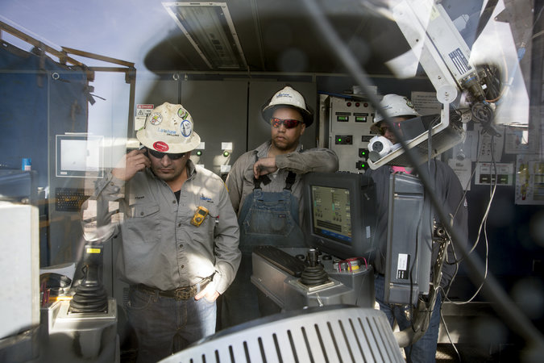
Cristo Flores, left, a driller, and Michael Manga, a rig manager, addressing an issue in a drillers’ cabin in Midland. Their rig, two years old, requires a smaller crew than in the past. Credit Ilana Panich-Linsman for The New York Times
But smaller companies and their workers are struggling to keep up.
S.O.C. Industries, a small local pump truck operator and chemical services provider, is forced to invest $100,000 a year to keep up with the computer programs and monitoring equipment its clients request. The added expenses are one reason the company has let go 15 of the 60 field workers employed three years ago. Another is that well operators that once hired five or six people on a drill site to mix chemicals and drilling fluids as well as clean up spills are now hiring only three as mechanization has sliced their drilling time in half.
Some of the remaining S.O.C. employees are straining to keep up with new computerized pump truck monitors and GPS systems.
“It’s a struggle,” said Rodrigo Urias, 59, an S.O.C. truck driver, who for many years only had to look at a needle on a gauge to monitor flow pressures. Now he needs to reset computer screens, take work orders on a computer tablet and sometimes do algebraic calculations.
“A lot of the guys can’t operate these new technologies, tablets and instruments, and they keep whining,” he added. “They want to know why we can’t do things like we used to.”
Manufacturing executives say they are trying to minimize the complexity for field workers, and sometimes design their equipment with the advice of video game makers.
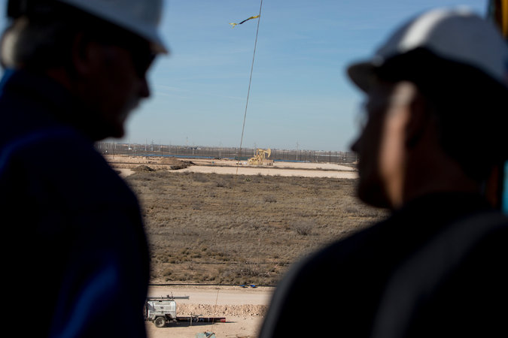
A view of a pumpjack in Midland. Credit Ilana Panich-Linsman for The New York Times
That’s a good thing for Michael Manga, 34, an employee of Latshaw Drilling, an Oklahoma company active here. A college dropout, he knocked around from job to job before finding his way to the oil patch. Now, playing video games like Call of Duty and Mario Kart with his friends over the years has paid off, giving him the eye-hand coordination to monitor and operate the control panels and joy sticks that control the drilling rig.
“We do such a good job now,” he said, “we’re drilling ourselves out of a job.”

